# 安装谷歌插件即可

<https://chrome.google.com/webstore/search/Octotree?utm_source=chrome-ntp-icon>

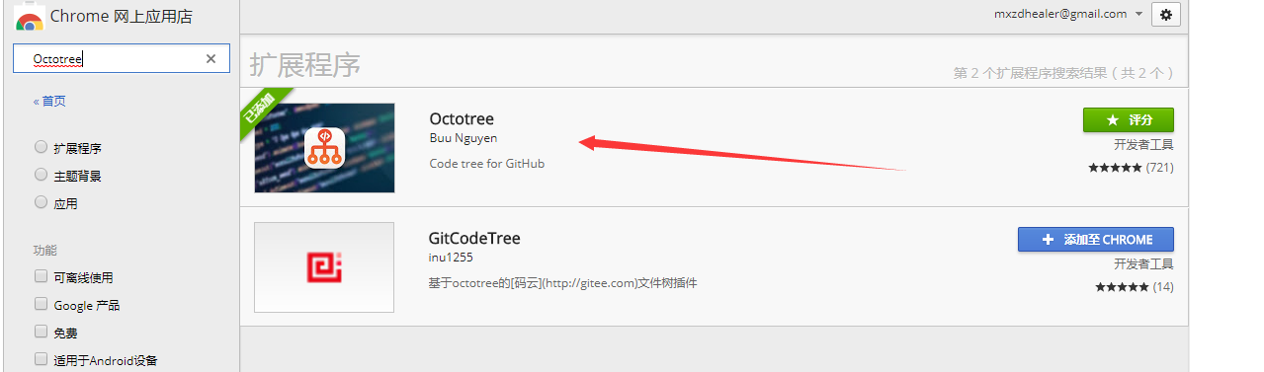

## 测试

